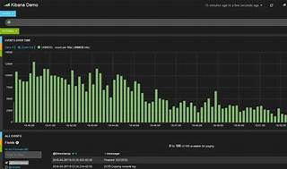

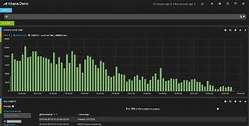

Explore

**Kibana** is an open-source browser-based visualization tool that lets you analyze large volumes of data from **Elasticsearch** and create various types of charts, maps, and dashboards. [It also manages security settings, user tasks, snapshots, and data roll-up within the **Elastic Stack**1](https://www.tutorialspoint.com/kibana/kibana_overview.htm).

Here are **five free reference links** where you can learn more about Kibana:

1. **Elastic Training**: Start your Elastic journey with free on-demand training. [Explore topics like enterprise search, observability, security, and more](https://www.tutorialspoint.com/kibana/kibana_overview.htm)[2](https://www.elastic.co/training/free).
2. **Kibana Fundamentals**: This self-paced, on-demand course provides 15 days of free access. [Learn how to query, analyze, and visualize Elasticsearch data using Kibana and Lens](https://www.tutorialspoint.com/kibana/kibana_overview.htm)[3](https://www.elastic.co/training/kibana-fundamentals).
3. **Guru99 Tutorial**: Discover what Kibana is and how it completes the ELK stack. [Explore interactive diagrams, geospatial data, and graphs for visualizing complex queries](https://www.tutorialspoint.com/kibana/kibana_overview.htm)[4](https://www.guru99.com/elk-stack-tutorial.html).
4. [**EDUCBA Kibana Training**: A 10+ hour video tutorial course with lifetime access to learn how to create visualizations using Kibana](https://www.tutorialspoint.com/kibana/kibana_overview.htm)[5](https://www.educba.com/data-science/courses/kibana-training/).
5. [**edX Kibana Course**: Learn to install, configure, and customize Kibana, import datasets, and create dashboards](https://www.tutorialspoint.com/kibana/kibana_overview.htm)[6](https://www.edx.org/learn/kibana).

Feel free to explore these resources and enhance your Kibana skills! 🚀